DEVELOPMENT SPECIFICATION
TalentBridge / Contact Manager
Staffing relationship and operational intelligence hub — complete flow for development
Jobs N Profiles | 8 September 2026 | Single source for the development team
HOW TO USE THIS DOCUMENT This is the whole development specification in one file: product principle, architecture, complete visual flows, modules, workspace behavior, integrations, privacy, POC scope, demonstration script, then the original developer questions with decisions at the end. TalentBridge in questions is Contact Manager in the product. Do not implement a contact database with integrations.

Companion files remain available for history. If anything conflicts, this document wins.
Part | Contents
A. Product | Principle, industry gap, data model, connected systems, POC vs later
B. Complete flow | 16 new diagrams plus the sample workspace — recruiter, sales, ops, leadership, submit, timeline, call, sync, Client 360
C. Build spec | Navigation, screen behavior, roles, integrations, privacy, delivery
D. Developer Q&A | Original TalentBridge questions with decisions (Q1–Q12, A1–A11, privacy)

A. Product

A.1 Product principle
PRODUCT PRINCIPLE TalentBridge Contact Manager is not another CRM and is not a replacement for JobsNProfiles, Outlook or VioTalk. It is the operational hub that connects them. JobsNProfiles = candidate/profile source. VioTalk = calling/recording/transcript engine. Outlook = email infrastructure. WhatsApp = messaging channel. TalentBridge = relationship + workflow + communication + action + intelligence hub. Later: other systems as connectors where technically and commercially feasible. A recruiter, BDM, operations user or manager should not have to search multiple applications to understand current state. Every important relationship has an owner, context and next action.

TalentBridge connects every candidate, client, vendor, requirement, submission, conversation, commitment and outcome—and makes sure every important relationship has an owner, context and next action.
The differentiation is not “everything is in one place.” It is that every relationship, conversation, commitment and outcome becomes connected data — and that nothing important is left without a next action. That is the industry gap and the product philosophy.

A.1a Product boundary
JobsNProfiles is the candidate/profile source. VioTalk is the calling/recording/transcript engine. Outlook is email infrastructure. WhatsApp is the messaging channel. TalentBridge is the relationship + workflow + communication + action + intelligence hub. Later connectors attach other systems only where technically and commercially feasible.

A.1b Priority improvements
P0 ships in the POC. P1 uses the same objects and SLA engine. P2 is intelligence on top — do not block P0 waiting for AI.
Priority | Improvement | Why it matters
P0 | Requirement/Job as first-class object | Connects candidate activity to actual business demand
P0 | Submission as business object | Enables real submission / interview / placement tracking
P0 | Unified communication timeline | Calls + email + WhatsApp + meetings + notes in context
P0 | Mandatory next action | Core “nothing falls through the cracks” capability
P0 | Candidate/contact ownership | Prevents duplicate effort; collaboration/transfer requests
P0 | Client 360 + Candidate 360 | Complete relationship picture for BDM, recruiter, ops, management
P0 | Outlook integration | Hub-first send + outside-mail capture as connected activity
P0 | VioTalk integration | Calls, recordings, transcripts and outcomes become operational data
P0 | JobsNProfiles integration | Candidate/profile data without duplicating JNP
P0 | SLA / aging engine | Neglected requirements, submissions, interviews, follow-ups, MSA
P1 | Relationship intelligence | Last contact, next action, health, response time
P1 | Vendor/supplier intelligence | Quality and performance of third parties
P1 | Placement follow-up | Lightweight check-ins after placement — not VMS
P1 | Source / data provenance | Where each field came from, sync status, manual override
P1 | Configurable workflows + custom fields | Stages, SLA days, ownership and alerts without code changes
P1 | Management action intelligence | What needs attention, not just activity totals
P2 | AI action intelligence | Extract commitments and recommended actions (Accept / Edit / Dismiss)
P2 | Natural-language / semantic search | Operational questions and recruiter queries such as “senior Java with Spring Boot, AWS, available, not submitted to this req”
P2 | Advanced relationship scoring | Client / candidate / vendor health scores
P2 | Redeployment intelligence | Re-engage placed candidates before assignments end
P0 | Candidate Search & Discovery (advanced filters) | Recruiter sourcing: title + skills + location + experience + owner + last contact; exclude already submitted; result context
P1 | Related-title search + title taxonomy | Java Developer also finds Java Engineer / Backend Java / Senior Java; DevOps → SRE / Platform / Cloud

A.2 The gap this fills
Staffing software grew up as specialist products. The recruiter’s day does not stay inside one of them: find a person, read what happened last time, call, submit to a client job, wait for a reply, schedule an interview, protect ownership, watch the PO, and not drop the follow-up.
- The job portal holds public/candidate profiles. It does not hold live conversations or submit a candidate to a client.
- The dialer places the call and stores a recording. The recruiter then re-types a note somewhere else.
- WhatsApp and email sit in a phone or inbox. “Send two DevOps profiles tomorrow” does not become a task on the requirement.
- Without a Job/Requirement object you can know that a resume went to ABC Company, but not for which req, who else was submitted, how fast, whether the client replied, or why it was rejected.
Contact Manager is built for that missing middle: the operating system of the staffing relationship.

A.3 Core data model
Keep the primary recruiting lifecycle simple: Client → Requirement → Candidate → Submission → Interview → Offer → Placement. Stop there. After Placement store only lightweight fields: Start Date, End Date, Client, Candidate, Owner, Follow-up, Placement Status. Do not create an Engagement Management or VMS module.
Layer | Objects TalentBridge owns
PEOPLE | Candidates; Client Contacts; Vendor Contacts; Internal Users
COMPANIES | Clients; Vendors
WORK | Requirements (Jobs); Submissions; Interviews; Placements
COMMUNICATIONS | Calls; Email; WhatsApp; Meetings; Notes; Transcripts
ACTION | Tasks; Follow-ups; Reminders; Approvals; Exceptions
COMMERCIAL | MSA; PO; Rates; Documents; Expiry
INTELLIGENCE | Search; Reports; KPIs; AI Insights; Risks; Opportunities; Audit

Connected system | They own | Hub uses them for
JobsNProfiles | Portal candidate profiles | One-way identity/skills in; never client submissions
Outlook / Microsoft | Mailbox send and receive | Compose/send from TalentBridge; also capture mail sent outside
VioTalk | Call placement, duration, recording ref, numbers | Click-to-call; one activity per call ID

A.4 POC vs architecture now
Build in POC | Schema now / intelligence later
P0 foundations: Requirement object, Submission object, unified timeline, mandatory next action on every channel, ownership banner + collaboration/transfer, Client 360 + Candidate 360, Outlook send+capture, VioTalk, one-way JNP, SLA/aging risks on the Dashboard. Core modules unchanged: Candidates, Clients, Vendors. Jobs on the Client, object ready for a later module. | P1/P2 later on the same objects: relationship scoring, vendor performance league tables, configurable SLA days/stages/custom fields, placement check-in cadence, redeployment intelligence, AI action extraction, natural-language search.

A.5 Ground rules
Rule | Meaning
Tenant scope | Every record, timeline, search hit, file, requirement, submission and audit event belongs to one tenant.
Modules | Core modules do not change: Candidates, Clients, Vendors. Also Dashboard, Calendar, Tasks, Communications, MSA & PO, Reports, Settings. Jobs/Requirements are work objects on the Client, not a core module. Sales flow on Client people: Lead → Suspect → Prospect → Customer (not extra menus).
Candidate profiles | JobsNProfiles is a job portal. TalentBridge stores the CRM candidate plus work and engagement.
Calling | VioTalk. Send contact ID + phone + signed-in user; upsert one activity by call ID.
Email | Outlook. Compose/send from TalentBridge; also ingest mail sent outside. No template catalog.
Work master | TalentBridge owns Requirements, Submissions, Interviews, Placements, Tasks, MSA/PO and audit.
Communication | Internal-only unified timeline. Not visible to candidates, clients or vendors.
No finance role | MSA/PO on Clients and Vendors; amounts permissioned; sales/ops maintain; leadership views.

B. Complete flow (visual)
The sample screen is the foundation layout. The diagrams that follow are the product flows developers should implement against that layout, with core modules unchanged (Candidates, Clients, Vendors), plus Submission objects, hub-first Outlook, relationship protection and action intelligence. Jobs live on the Client.

B.1 Sample workspace (foundation UI)
Three panes: left navigation, middle list, right working profile. Keep this stay-on-page model. Core modules do not change: Candidates, Clients, Vendors. Change action labels so they launch live channels (VioTalk, Outlook compose, WhatsApp) instead of blank log forms. Jobs/Requirements are work objects on the Client and are selected at Submit Profile — they are not a fourth core module.
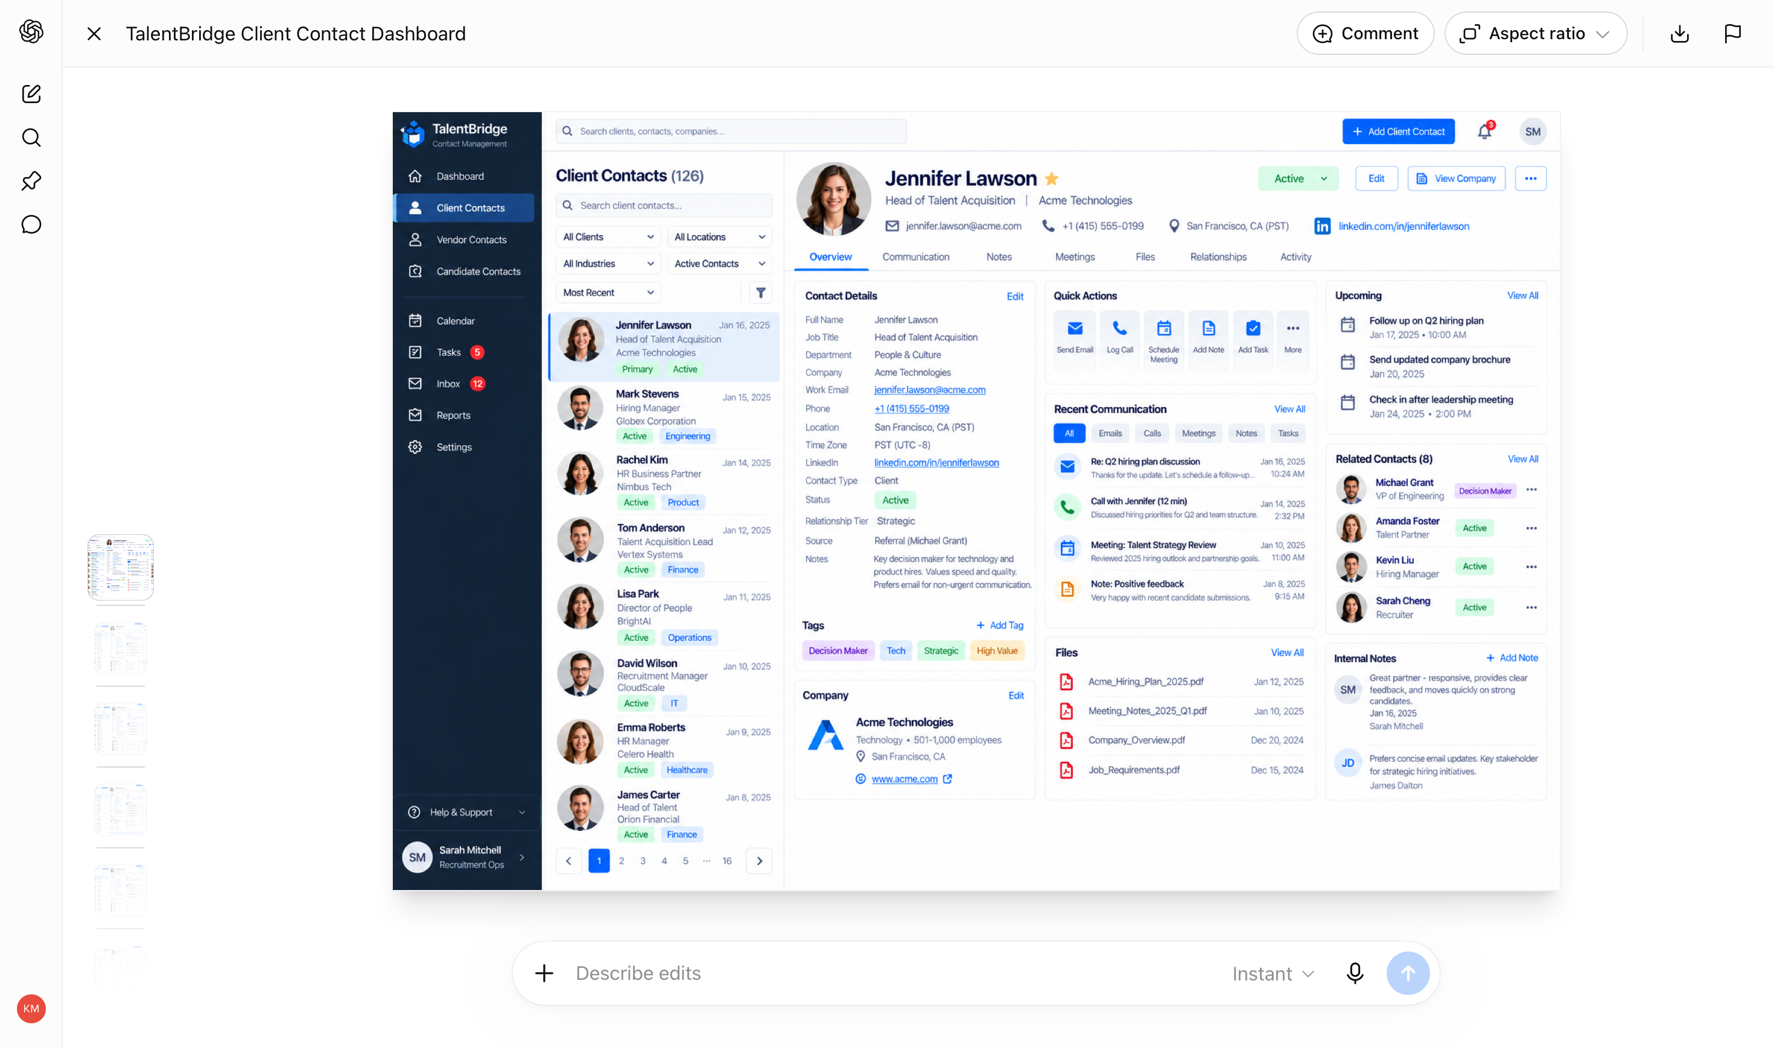
Figure 0. Sample TalentBridge workspace used as the visual foundation (Jennifer Lawson / Acme Technologies).

B.2 Hub architecture
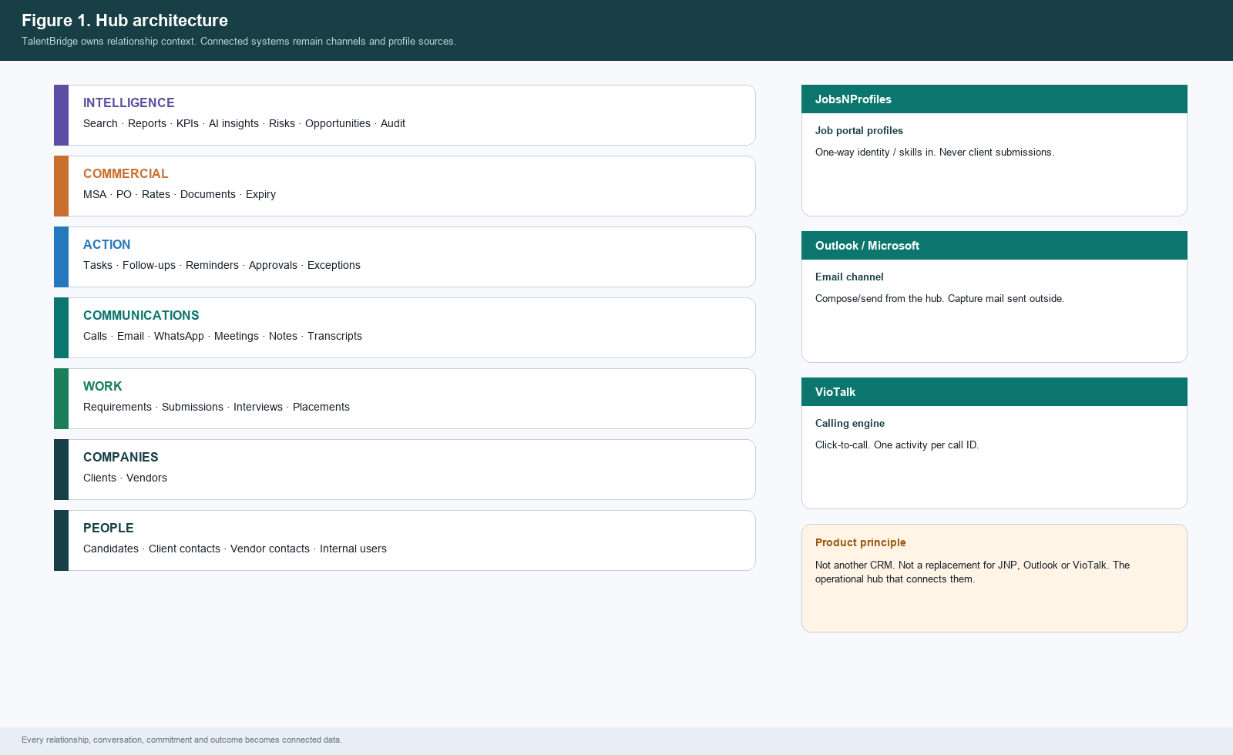
Figure 1. Hub architecture — TalentBridge layers and connected systems.

B.3 Staffing lifecycle
A submission without a requirement cannot answer “for which job?” Submission is a business object with an ID and a lifecycle, evidenced by email, not equal to an email.
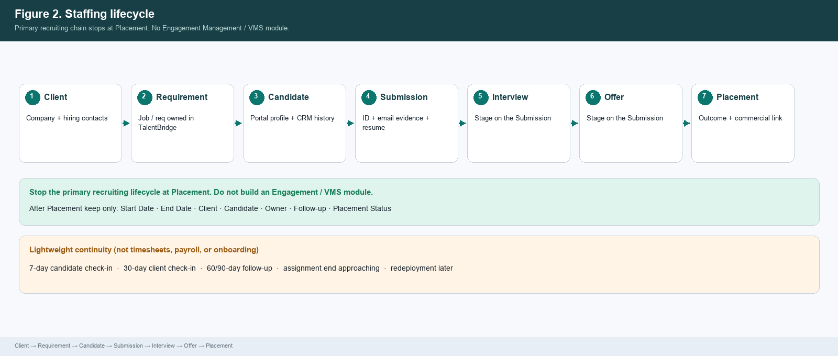
Figure 2. Staffing lifecycle and Submission ID links.

B.4 Operating model
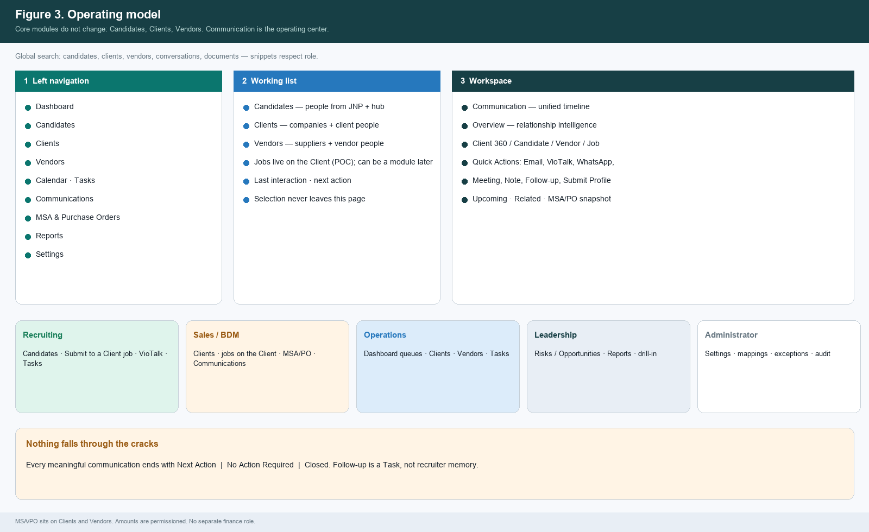
Figure 3. Operating model — three-pane workspace, roles, wrap-up rule.

B.5 Recruiter / delivery journey
- Land on the Candidates module.
- Find the person; read JobsNProfiles profile context (one-way sync).
- If already owned, show the protection banner (owner, last contact, active requirement, recent activity) with Request Collaboration and Request Transfer. Do not auto-merge.
- VioTalk Call on the assigned number; profile stays visible; disposition required.
- Wrap-up: Next Action, No Action Required, or Closed.
- Submit Profile: select Requirement, client contact, attach resume, compose in the hub, send through Outlook.
- Submission ID writes to candidate, requirement and client. Client reply can move stage. Continue to the next list card; filters survive.
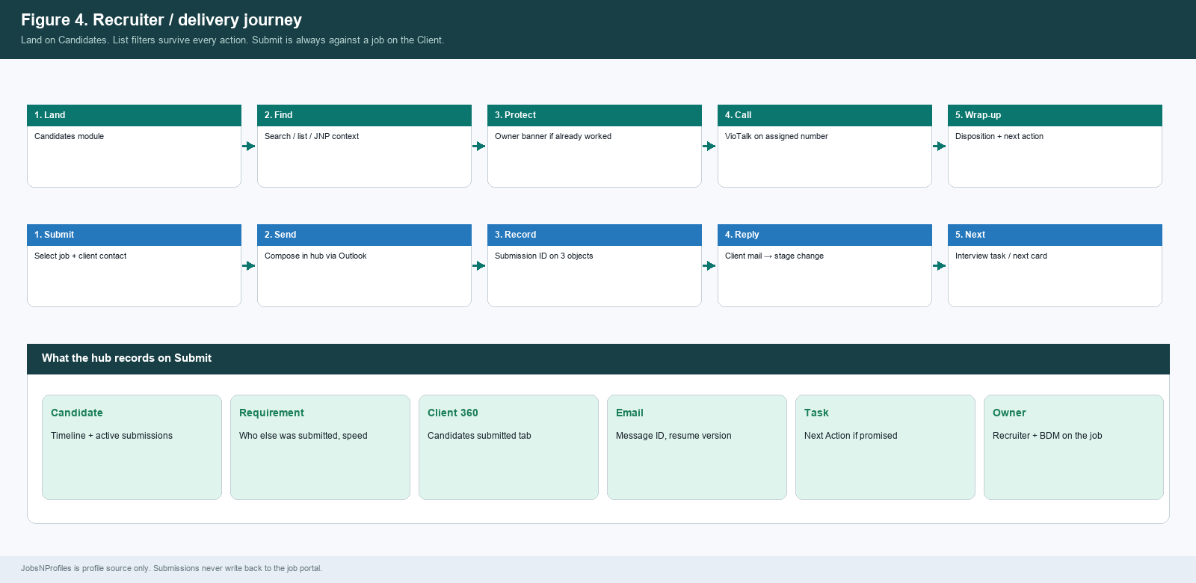
Figure 4. Recruiter / delivery journey including Submit against a Requirement.

B.6 Sales / BDM journey
- Create or import the Client in TalentBridge (not from JobsNProfiles).
- Stage Lead → Suspect → Prospect → Customer is permissioned (owner, sales/ops/admin). Stage change does not wipe history. Customer is the won stage; the module remains Clients.
- Open a Requirement on the Client (hiring manager, skills, BDM, assigned recruiters).
- Engage from Quick Actions. Review Client 360 including MSA/PO snapshot.
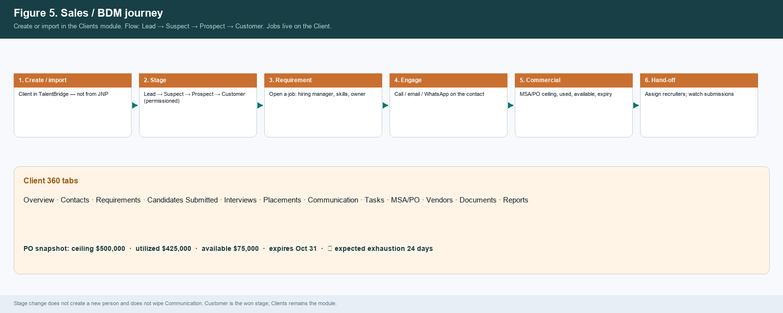
Figure 5. Sales / BDM journey and Client 360 tabs.

B.7 Operations and leadership
Dashboard leads with Today’s Risks and Today’s Opportunities (rule-based in POC). Activity KPIs are the second block. Every tile click-throughs to the live record. Operations works the queue; leadership sees the same objects as risk.
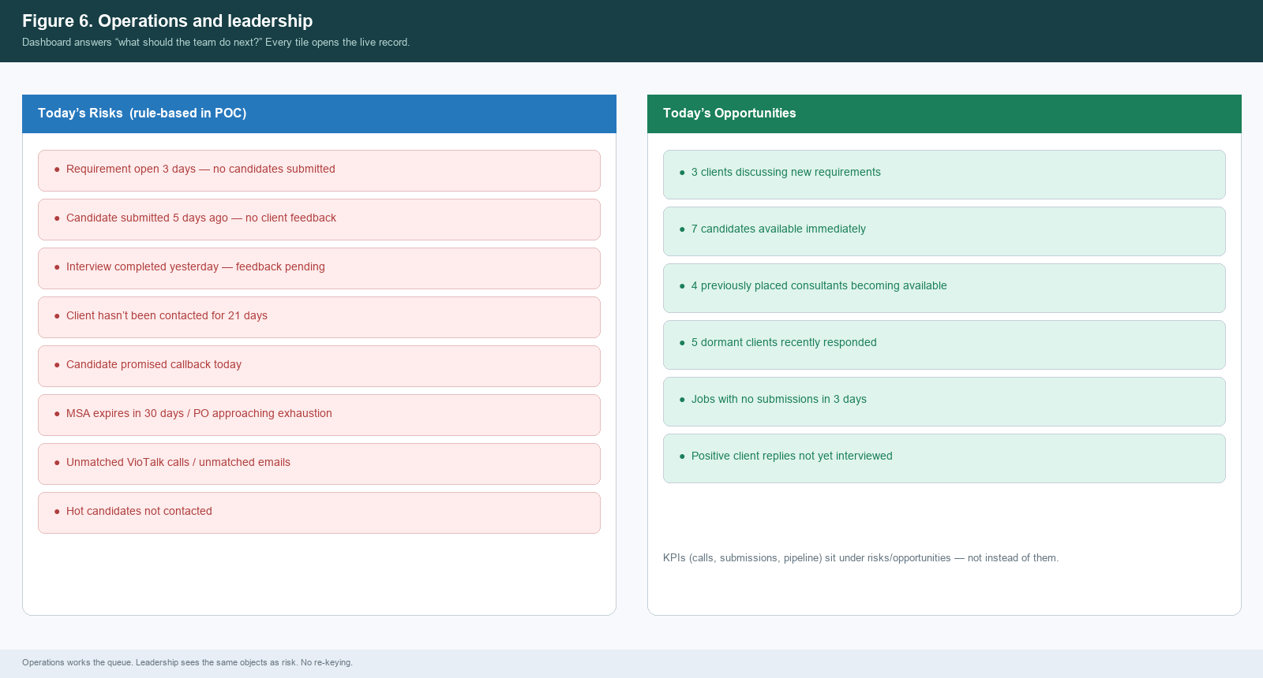
Figure 6. Dashboard action intelligence — risks and opportunities.

B.8 Submit Profile — Outlook hub-first and outside capture
Preferred path: compose and send from TalentBridge through the signed-in user’s Outlook account. Parallel path: Microsoft Graph watches sent and inbound mail and associates it. No TalentBridge template catalog. Unmatched mail goes to a review queue.
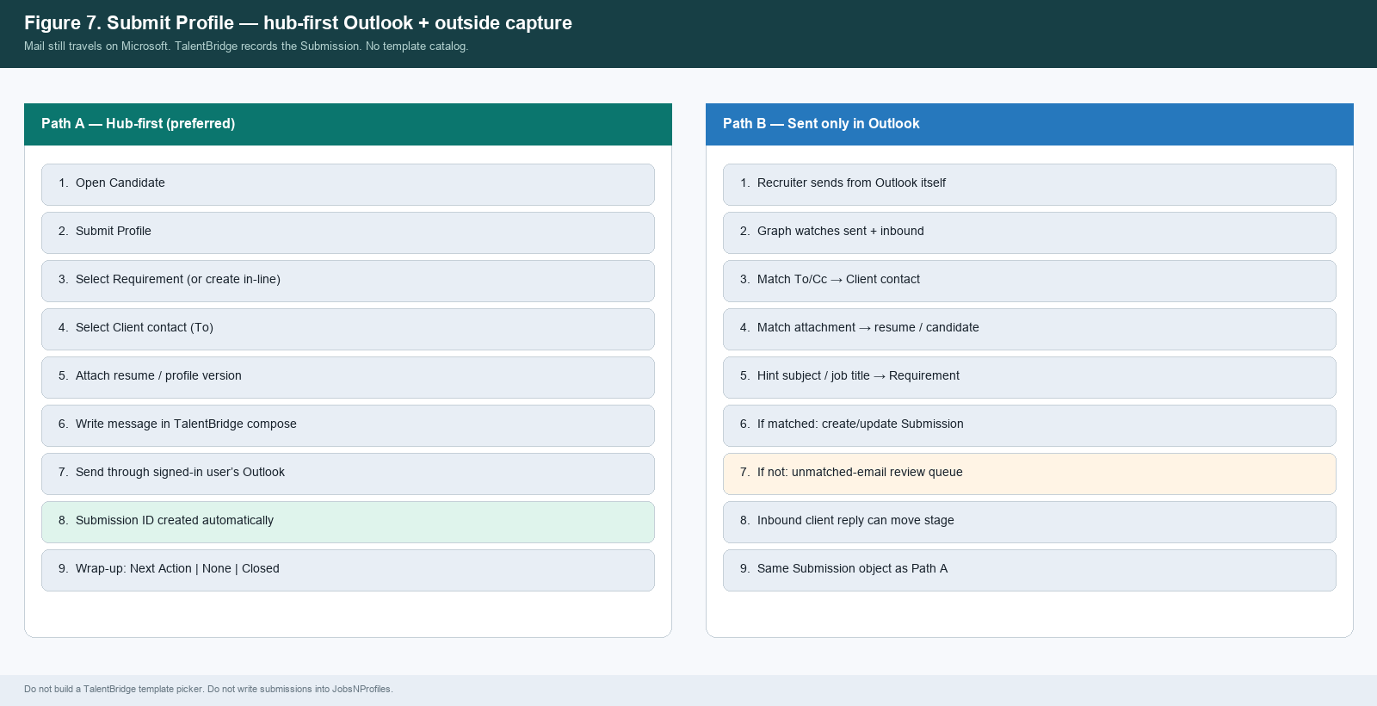
Figure 7. Hub-first send and outside-Outlook capture — same Submission object.

B.9 Unified timeline
Communication is the system of record for authorized internal users. The timeline shows what was said and what it caused, on the person, company, requirement and submission.
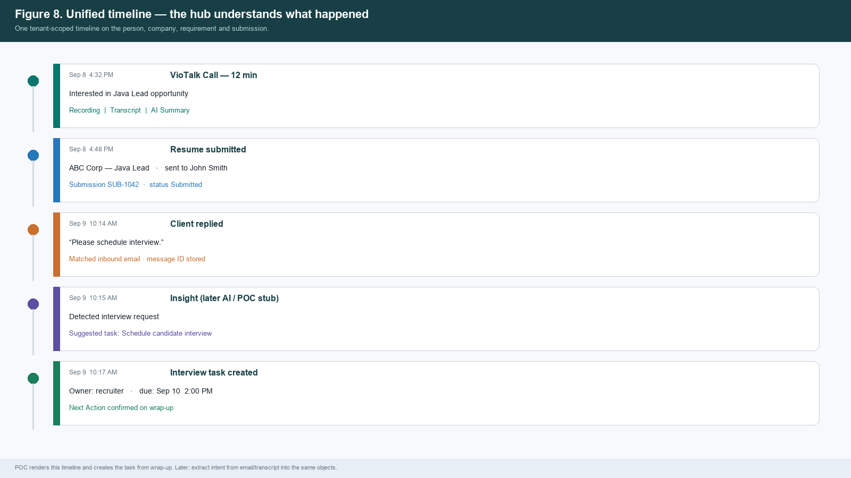
Figure 8. Example unified timeline from call to interview task.

B.10 VioTalk
TalentBridge sends contact ID + phone + signed-in user. VioTalk places the call on the assigned number. One activity keyed by VioTalk call ID. Recording / transcript / AI summary when permitted. Proposed follow-up becomes a Task after wrap-up. Not every TalentBridge role needs a VioTalk seat.
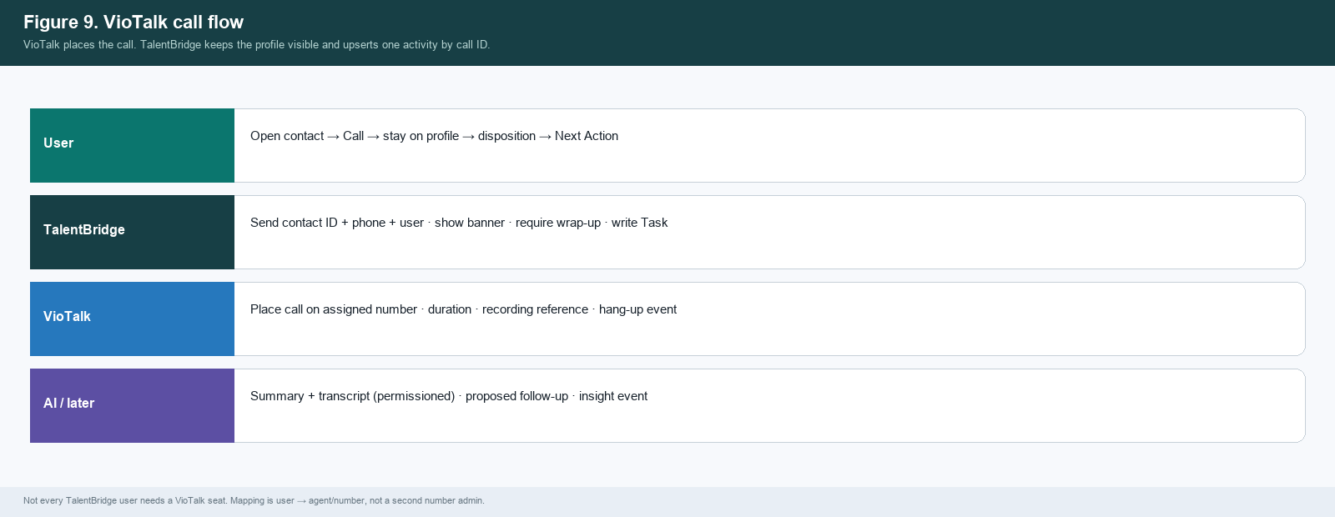
Figure 9. VioTalk swimlane.

B.11 Candidate sync and ownership
One-way: JobsNProfiles portal profile → upsert TalentBridge Candidate by portal candidate ID. Email/phone collisions go to duplicate review with an ownership banner. Never auto-merge. Never push TalentBridge contacts into JobsNProfiles.
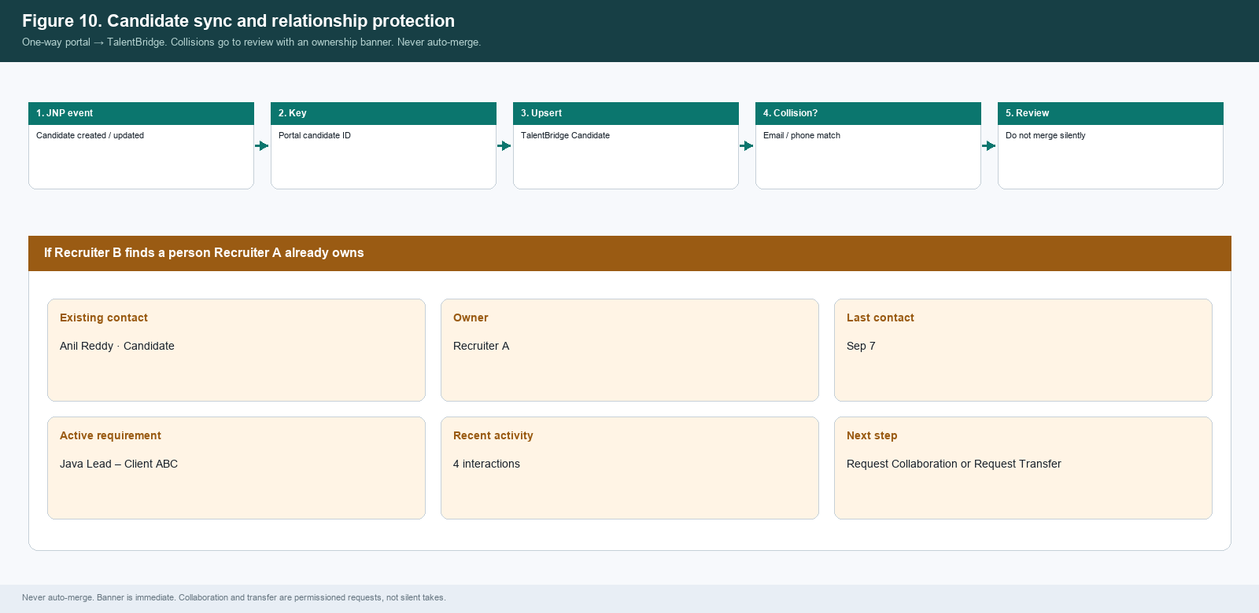
Figure 10. Sync flow and relationship-protection banner.

B.12 Nothing falls through the cracks
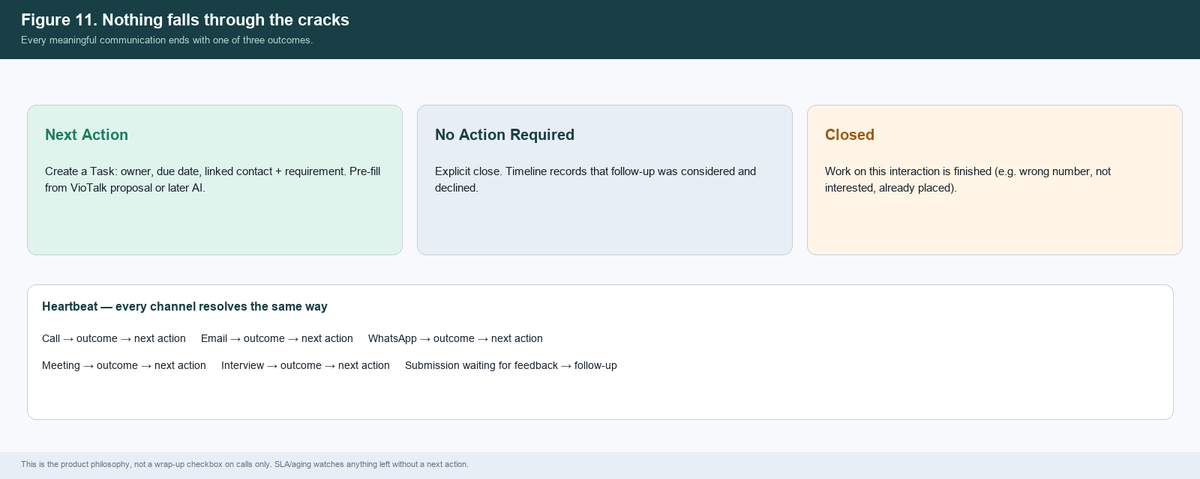
Figure 11. Required wrap-up outcomes and example task extraction.

B.13 Client 360 and Vendor
Opening a Client shows the whole relationship. Overview intelligence: Relationship Owner, Last Contact, Next Action, Open Requirements, Submissions, Interviews, Placements, Average Client Response Time, Requirement Aging, Relationship Health, MSA Status, PO Risk, Recent Commitments. Vendor remains a major module (contacts, candidates, submissions, agreements, rates, compliance) with performance metrics later.
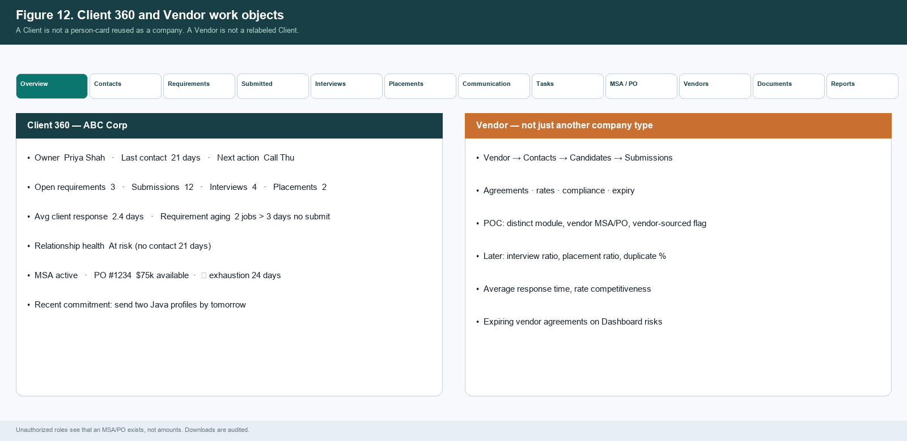
Figure 12. Client 360 tabs and Vendor work objects.

B.14 MSA and purchase orders
Tenant Client and Vendor MSA/POs created in TalentBridge by sales and operations. Not JobsNProfiles MSAs. Not a finance module. Queue: pending review, notice window, low remaining value, exhausted, expected exhaustion.
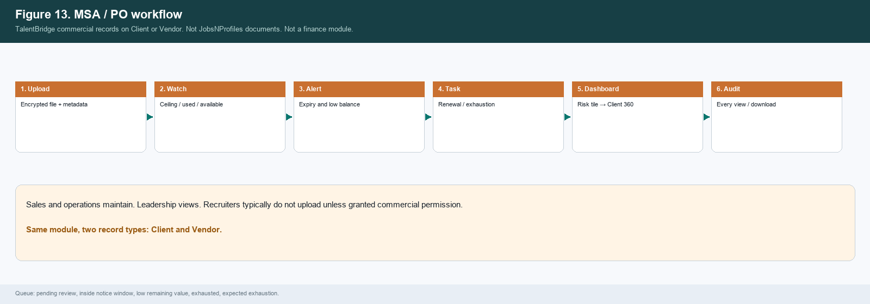
Figure 13. MSA/PO workflow.

B.15 Search and stay-on-page
Two search surfaces. (1) Global search is a jump-to-record bar. Groups, omit empty: Candidates, Clients, Vendors, Conversations, Documents. Jobs and submissions open on the Client or Candidate they belong to. (2) Candidate Search & Discovery lives on the Candidates module — that is the recruiter sourcing workflow and is specified in C.15. Natural-language operational search is later (C.16). Snippets never leak PO amounts, recordings or internal-note bodies.
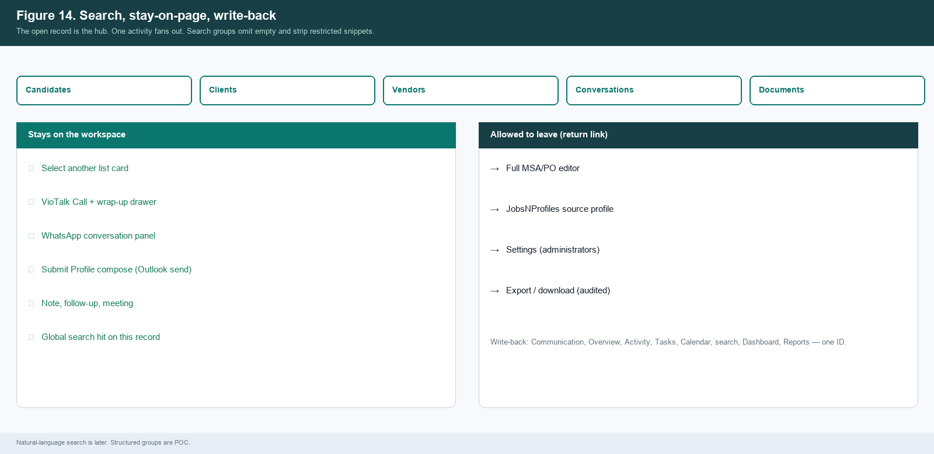
Figure 14. Search groups and stay-on-page map.

B.15a Candidate discovery surface
The Candidates list is not only a directory. It is the discovery surface: filters first (POC), related titles next (MVP), semantic queries later — all on one title/skills/submission index.
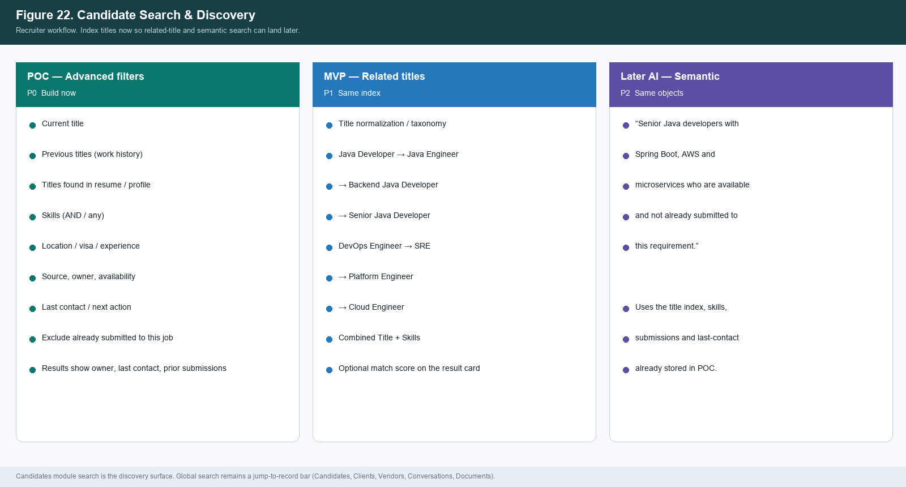
Figure 22. Candidate Search & Discovery — POC filters, MVP related titles, later semantic search.

B.16 Administrator and privacy
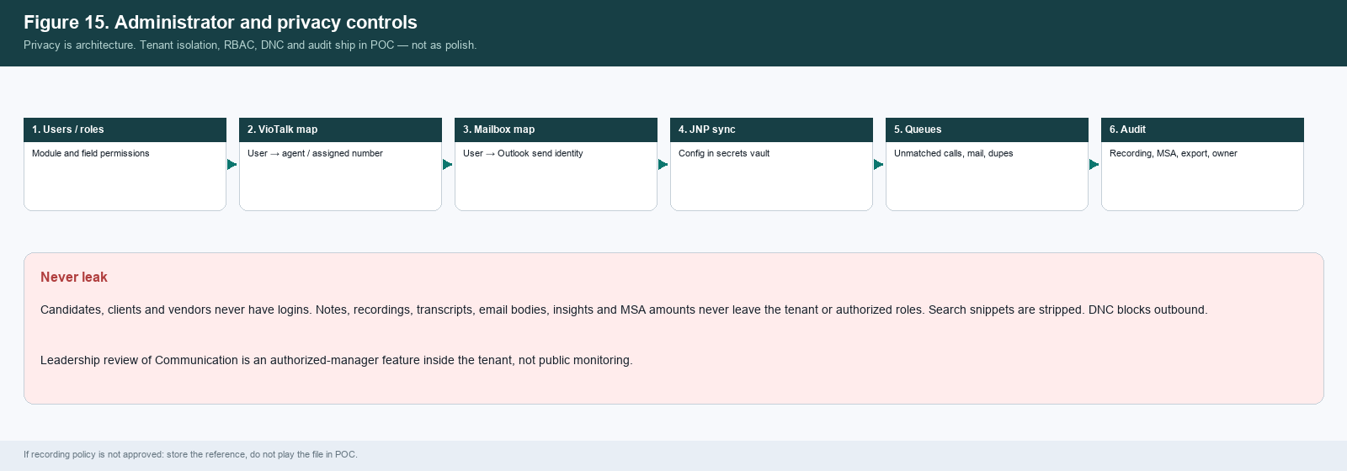
Figure 15. Admin mapping, exception queues, audit and privacy controls.

B.17 Demonstration spine
POC demo must prove the hub in one sitting, not five disconnected integration demos.
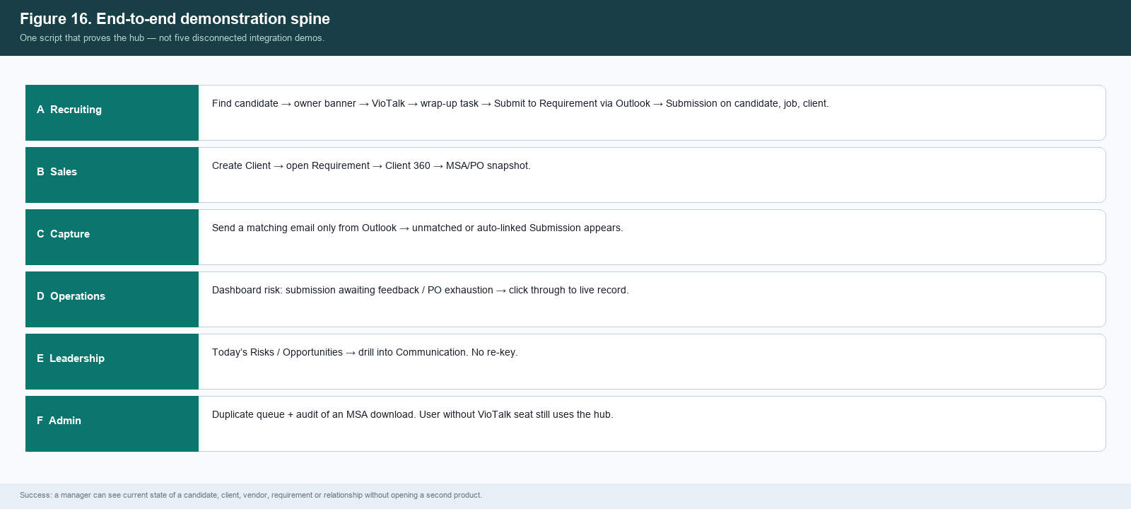
Figure 16. End-to-end demonstration spine.

B.18 Candidate 360
Give candidates the same operational depth as Client 360. Header: Owner, Last Contact, Next Action, Current Status, Active Requirements, Submissions, Interviews, Source (JobsNProfiles), Last Resume.
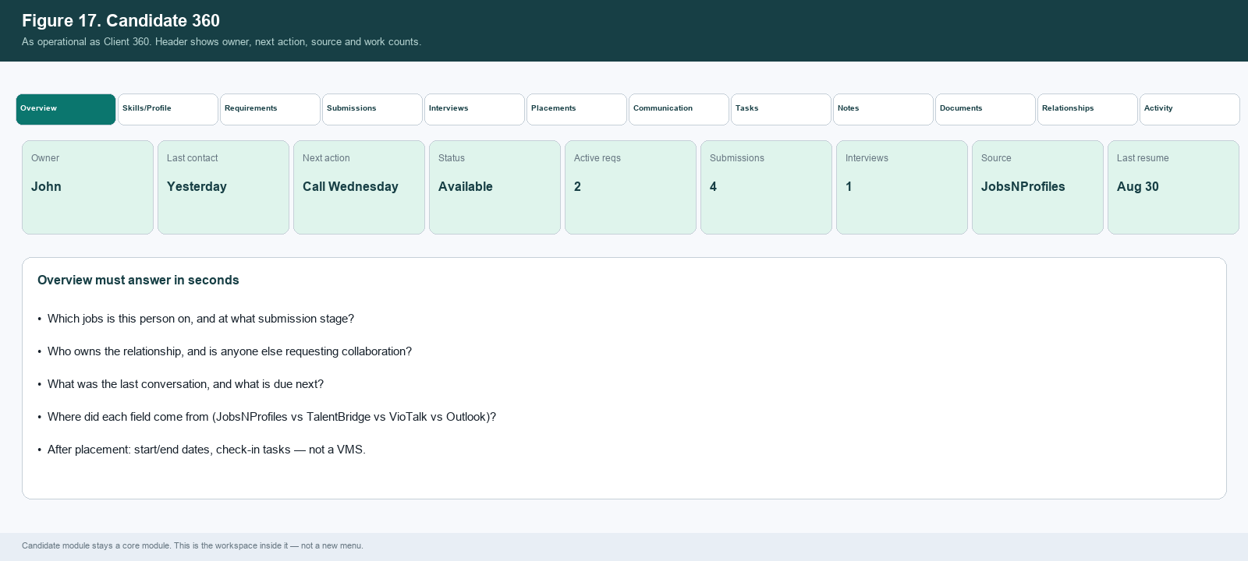
Figure 17. Candidate 360 workspace.

B.19 Data provenance
Because TalentBridge is not the master of every field, every value must carry source_system, external_id, source_timestamp, last_synced_at, sync_status, updated_by and manual_override.
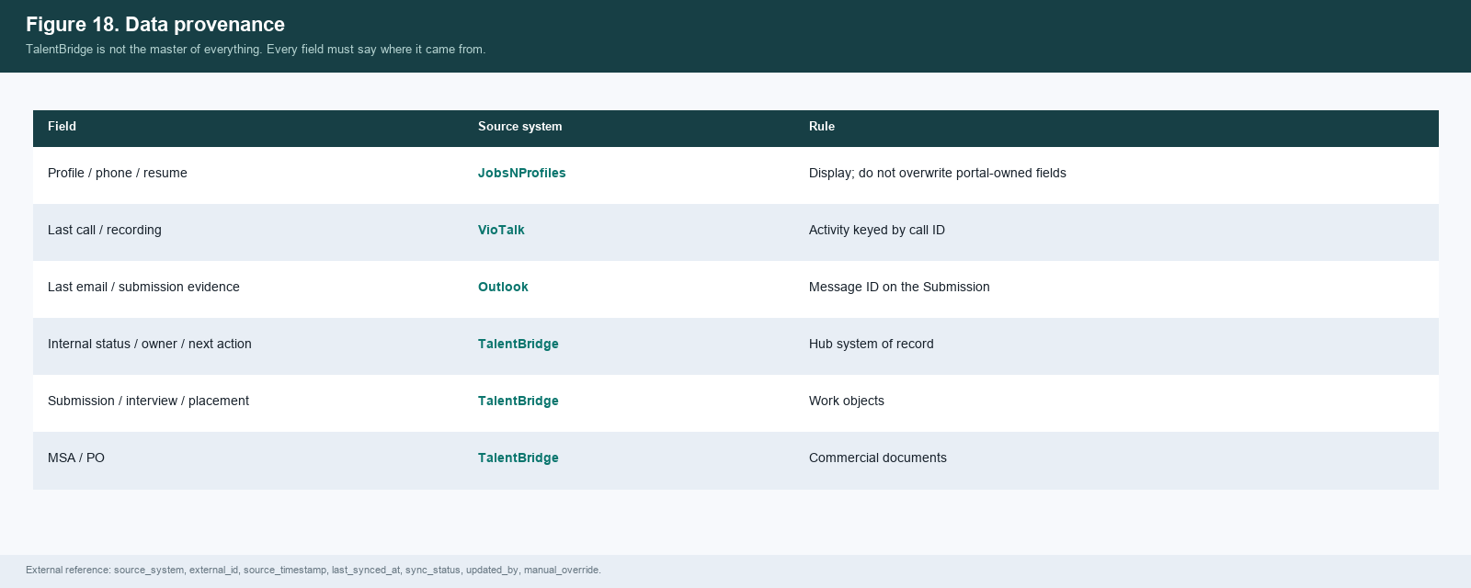
Figure 18. Field-level provenance.

B.20 Product boundary
Keep this boundary explicit so development does not accidentally rebuild JNP, VioTalk, Outlook or a VMS.
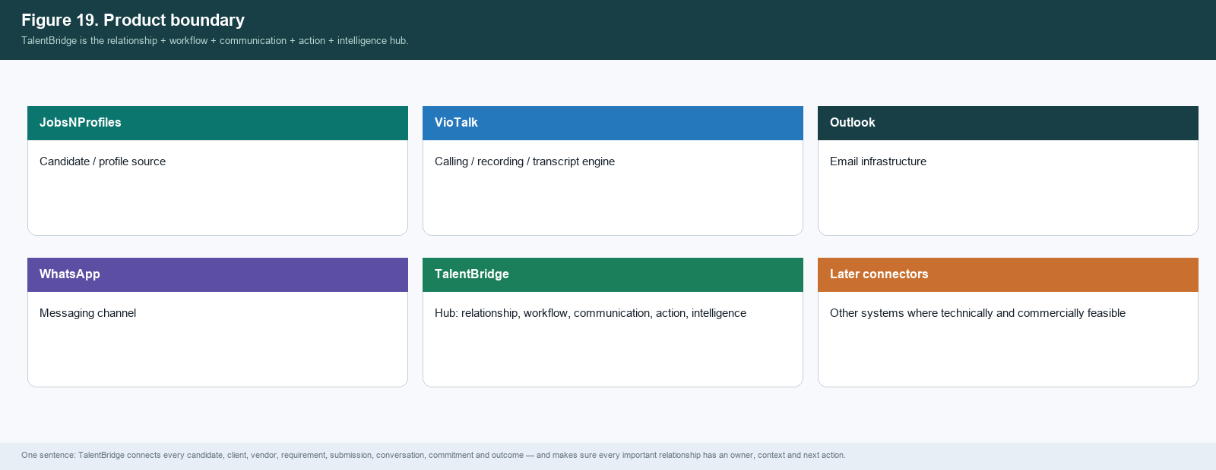
Figure 19. Product boundary.

B.21 Requirements — module-ready later
POC keeps jobs on the Client. Recruiter day-start is often “which requirements need candidates today?” Preserve that flexibility in the object model and filters.
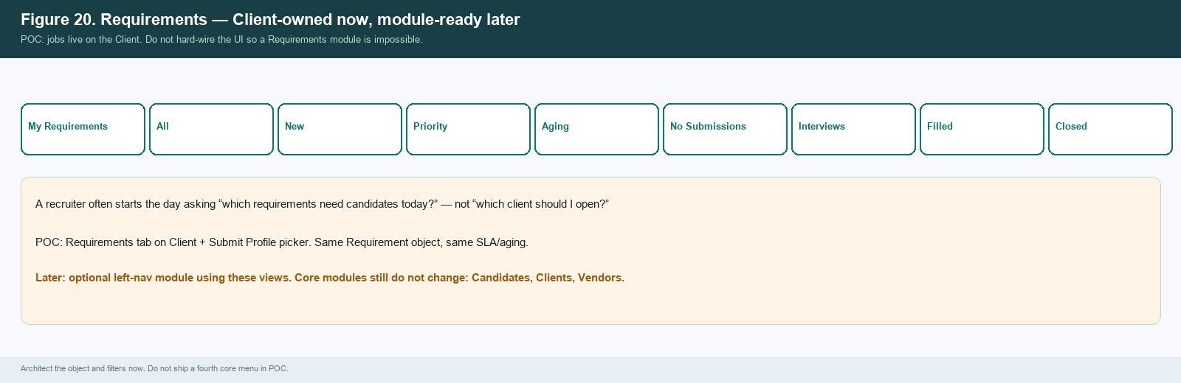
Figure 20. Requirements views for a later module.

C. Build specification

C.1 Navigation modules
Module | Primary users | Opens
Dashboard | Leadership, operations, sales, recruiting | Today’s Risks / Opportunities first; overdue follow-ups; integration health; MSA/PO watchlist
Candidates | Recruiting, operations, leadership | Candidate people. Portal profile context, submissions, VioTalk, Submit Profile against a Client job.
Clients | Sales, operations, leadership | Client companies and client people. Sales flow: Lead → Suspect → Prospect → Customer. Jobs, submissions, MSA/PO on this record.
Vendors | Sales, recruiting ops, operations | Supplier companies and their people; vendor-sourced candidates; vendor MSA/PO
(not a module) Jobs | Not a core module | Work object on the Client (Requirements tab) and the Submit Profile picker. Do not add a fourth core menu.
Calendar | All working roles | Meetings, follow-ups, interviews, MSA reviews, PO renewals
Tasks | All working roles | Open, due, overdue, assigned — including wrap-up next actions
Communications | Sales, recruiting, operations, leadership | Org-wide inbox across VioTalk, WhatsApp, email, meetings
MSA & PO | Sales, operations, leadership (view) | Agreements and POs for Clients and Vendors
Reports | Leadership, operations, managers | Pipeline, activity, follow-up, call, commercial — click through to live records
Settings | Administrator | Users, roles, VioTalk/mailbox maps, JNP sync, retention, audit

C.2 Workspace behavior
- Selecting a list card opens the record in the right pane. List filters stay. Core lists are Candidates, Clients and Vendors.
- Tabs on a Candidate: Overview | Skills/Profile | Requirements | Submissions | Interviews | Placements | Communication | Tasks | Notes | Documents | Relationships | Activity. Header: Owner, Last Contact, Next Action, Current Status, Active Requirements, Submissions, Interviews, Source, Last Resume. Client people stay on the Clients module.
- Tabs on a Client company: Overview | Contacts | Requirements | Candidates Submitted | Interviews | Placements | Communication | Tasks | MSA/PO | Vendors | Documents | Reports. Overview shows the intelligence fields in A8.
- Quick Actions: Send Email, VioTalk Call, WhatsApp, Schedule Meeting, Add Note, Add Follow-up, Submit Profile (candidates only), More.
- Submit Profile compose: Requirement + Client contact + resume + message. Send via Outlook. Creates Submission ID. Wrap-up required.
- Do Not Contact disables outbound call / WhatsApp / email; UI explains why.
- Overview relationship intelligence is required on Client and Candidate — not identity fields only. See Client 360 and Candidate 360 lists. Flags come from the SLA/aging engine.

C.3 Submission object
Field / link | Rule
Submission ID | TalentBridge-generated, tenant-scoped
Candidate, Requirement, Client, Client contact | Required. Cannot submit “to a company” with no job.
Recruiter, BDM | Recruiter = sender/owner; BDM from the Requirement
Email message ID, resume version, sent time | Evidence; not a substitute for the object
Lifecycle | Submitted → Client Review → Interview → Rejected → Offer → Placement
Stage change | Permissioned, audited, written to timeline on candidate + client + requirement
Source | Hub send (preferred) or ingested Outlook mail

C.4 Requirement object (minimum POC)
Field | Notes
Title, skills, location | Searchable
Client company, hiring-manager contact | Required
Owner (BDM), assigned recruiter(s) | Required for ownership and reporting
Status | Open / On hold / Filled / Cancelled
Opened date, target fill date | Dashboard ageing
Optional portal job ID | If JobsNProfiles later exposes jobs; not required in POC

C.5 Roles
Role | Default landing | Notes
Recruiting / delivery | Candidates | Submit Profile to a Client job, VioTalk, tasks
Sales / BDM | Clients | Create clients/requirements; MSA/PO maintain; stage permission
Operations | Dashboard | Queues: follow-up, unmatched calls/mail, sync exceptions, MSA/PO, submission feedback
Leadership | Dashboard | Risks/opportunities; read-heavy; no VioTalk seat required
Administrator | Settings | Maps, permissions, exceptions, audit. May have no VioTalk seat

C.6 Integrations
System | Owns | TalentBridge does
JobsNProfiles | Portal profiles | One-way sync in; deep link; exception queue. No submission write-back.
VioTalk | Call placement, duration, recording ref, numbers | Click-to-call; upsert by call ID; unmatched-call queue; user↔agent map
WhatsApp (later slice) | Company numbers, delivery | Conversation panel on the contact if built. Not used for client submissions.
Outlook / Microsoft | Mailbox transport | Send as user from workspace; read sent/inbound; Submission create/update; unmatched queue
TalentBridge | Hub objects listed in A.3 | System of record for the operating platform

C.7 Event processing
- Receive event (VioTalk webhook, Graph mail, JNP candidate webhook, user action).
- Authenticate and tenant-scope.
- Map durable IDs (portal candidate ID, VioTalk call ID, Outlook message ID, TalentBridge object IDs).
- Upsert the hub object (Contact, Submission, Activity, Task). Never silent-merge people.
- Fan out: Communication, Overview, Activity, Tasks, Calendar, search index, Dashboard tiles.
- On failure: exception queue with retry of safe operations only.

C.8 Privacy and security (POC, not polish)
- Tenant isolation on every query (contacts, companies, requirements, submissions, activities, files, insights, search).
- Candidates, clients and vendors never have logins and never see Notes, recordings, transcripts, email bodies, insights or MSA/PO files.
- Role permissions: commercial values and download; recording/transcript/AI summary; export; ownership transfer.
- Search snippets must not leak restricted values.
- Call recording follows consent and retention. If unapproved, store the reference but do not play in POC.
- Audit: who viewed/downloaded a recording or MSA/PO, who exported, who changed a role or owner.
- Do Not Contact disables outbound call/WhatsApp/email.
Leadership review of Communication is an authorized-manager feature inside the tenant, not public monitoring.

C.9 Minimum entity model
Entity | Key relationships | Minimum fields
User / Team | Owns records, tasks, mappings | Identity, role, team, status, VioTalk agent, mailbox
Company | Has contacts, requirements, MSA/PO | Name, type Client/Vendor, owner, industry, location
Contact | Belongs to company; has activities | Type/stage, identity, channels, owner, source, DNC, status
Requirement | Belongs to client; has submissions | Title, hiring manager, BDM, recruiters, status, dates
Submission | Candidate + requirement + client + email | Status lifecycle, recruiter, message ID, resume version
Activity | Belongs to contact / company / req / submission | Kind, summary, source, external ID, timestamps
Task | Belongs to contact/company/requirement | Owner, due, priority, status, source event; used for wrap-up, SLA follow-up, placement check-ins
Insight | Links to activity and optional task | Type, confidence, proposed/accepted/dismissed
Document / MSA / PO | Belongs to company | Type, versions, dates, ceiling/utilized/available, access class
Provenance / external reference | Links any field/object to JNP / VioTalk / Graph / TalentBridge | source_system, external_id, source_timestamp, last_synced_at, sync_status, updated_by, manual_override
Audit event | Any sensitive action | Actor, action, entity, before/after, timestamp
Title index / taxonomy | Belongs to Candidate; used by search | current_title, previous_titles[], resume_titles[], normalized_title_id, related_title_ids, skills[], last_indexed_at

C.10 POC delivery
Week | Focus
1 | API discovery: JNP profile API, VioTalk mapping, Graph send-as-user + mailbox read, minimum Requirement fields, recording policy, commercial permissions
2 | People/companies CRUD, ownership banner, Requirements CRUD, unified timeline shell, wrap-up, Candidate Search & Discovery index (current title, previous titles, resume titles, skills) and POC filters.
3 | Submit Profile send + Outlook ingest, Submission lifecycle, VioTalk click-to-call write-back, JNP one-way sync
4 | Client 360 + Candidate 360 + MSA/PO snapshot, Dashboard risks/opportunities, unmatched queues, Candidate search result context (owner, last contact, prior submissions, exclude already submitted), UAT on the demonstration spine.

Item | Owner | Why it blocks build
JobsNProfiles portal candidate API | Technical + recruiting | One-way profile sync only
Microsoft Graph send as user + read sent/inbound | Technical | Hub-first submit and outside-mail capture
VioTalk user/number read API | Technical | Mapping should sync, not be retyped
Recording consent / retention | Legal + operations | If unapproved, hide playback
Who may see amounts, recordings, transfer ownership | Sales + ops + leadership | Field-level matrix
Requirement fields for POC | Sales + recruiting | Cannot submit without a job
JNP title / skills / work-history fields for search index | Technical + recruiting | C.16 POC filters need current title, previous titles and skills from the one-way profile sync

C.11 Acceptance (POC is ready when)
- A user can search and open Candidates, Clients and Vendors in the three-pane workspace without losing list filters. On Candidates, POC advanced filters work: current title, skills, location, experience, source, owner, availability, last contact, and exclude already submitted to the open requirement. Result cards show owner, last contact and previous submissions.
- Submit Profile selects a Requirement and client contact, sends through Outlook with no template catalog, and creates a Submission ID on candidate, job and client.
- An email sent only in Outlook is either linked to a Submission or sits in unmatched review.
- A VioTalk call writes one activity by call ID; wrap-up requires Next Action, No Action Required, or Closed.
- A JNP candidate upserts by portal ID; a collision shows the ownership banner and never auto-merges.
- Client 360 shows requirements, submissions and MSA/PO snapshot; amounts hide without permission.
- Dashboard Today’s Risks / Opportunities click through to live records.
- Tenant isolation and RBAC hold on search snippets, recordings and MSA files.
- The demonstration spine (Figure 16) completes without manual database edits.

C.12 SLA / aging engine (build now)
Configurable SLA days (defaults below). The Dashboard Today’s Risks tiles are queries over these rules, not a separate reporting product. Defaults: requirement with no submission in 3 days; submission with no client feedback in 5 days; interview with no feedback the next business day; client last-contact > 21 days; promised callback due today; MSA expiry inside 30 days. Admin can change the day counts later without a code change — store them as tenant settings now.

C.13 Placement continuity (lightweight)
When Placement is created, store Start Date, End Date, Client, Candidate, Owner, Follow-up, Placement Status. Auto-create Tasks: 7-day candidate check-in, 30-day client check-in, 60/90-day relationship follow-up, assignment-end approaching. Redeployment intelligence is P2. This is not timesheets, payroll, or onboarding.

C.14 Configurable workflows (schema now, UI next)
Do not hard-code stage lists or SLA days. Tenant settings must be able to hold: relationship stages (default Lead → Suspect → Prospect → Customer), submission stages, required fields, SLA days, ownership rules, follow-up rules, role permissions, custom fields, dashboard alert rules. POC ships the defaults. Admin UI for editing them is P1.

C.15 Candidate Search & Discovery
Candidate discovery is a core recruiter workflow and must be in the architecture now, not an afterthought. Global search (Q12) is the jump-to-record bar. Candidate Search & Discovery is the sourcing surface on the Candidates module (and can be opened from a Requirement as “find candidates for this job”). Index titles and skills during the one-way JobsNProfiles sync so MVP related-title search and later semantic search reuse the same index.
Index, for every candidate: current title; previous titles from work history; titles extracted from the resume/profile text; skills; location; experience; availability; source; owner; last contact; next action; submissions (requirement IDs). Tenant-scoped. Unauthorized roles never see restricted snippets.
When opened from a Requirement, the search is pre-scoped: exclude already submitted is on by default; result actions include Submit Profile to this job. When opened from the Candidates module, the recruiter may optionally pick a requirement to apply that exclusion. Ownership banner still applies if Recruiter B opens a result owned by Recruiter A.
Level | Depends on | What to build
POC — Advanced filters (build now) | Exact/contains filters, no taxonomy required yet | Title (current) + Skills + Location + Experience + Source + Owner + Availability + Last Contact. Also search previous titles and titles appearing in the resume/profile as additional title fields. Combined Title + Skills. Exclude candidates already submitted to the open requirement. Result card: name, current title, skills snippet, location, owner, last contact, next action, previous submissions (client + job + stage). Optional simple rank: recency of contact + skill overlap.
MVP — Related-title search | Same index + title taxonomy | Normalize titles onto a taxonomy. Query “Java Developer” also returns Java Engineer, Backend Java Developer, Senior Java Developer. “DevOps Engineer” also returns SRE, Platform Engineer, Cloud Engineer. Recruiter can toggle Related titles on/off. Show why it matched (current / previous / resume / related). Match score on the card.
Later AI — Semantic search | Same objects, no second stack | Natural language: “Find senior Java developers with Spring Boot, AWS and microservices who are available and haven’t already been submitted to this requirement.” Uses title index, skills, availability, last contact and submission exclusions already stored. Management NL questions stay in C.15 and share this index.

C.16 Natural-language search (P2, same objects)
Management NL search is C.16 (P2) on the same objects, for example: clients with open requirements but no submissions; recruiters with overdue follow-ups. Recruiter semantic discovery is specified in C.15 Later AI and must reuse the title/skills/submission index built in POC — do not add a second search stack.

D. Developer questions and answers
This part answers Talent Bridge App Quetions.docx. Architecture decisions A1–A11 were not on that list; they are product decisions and are in scope. Original wording is kept in the question titles.
SEND THIS TO DEVELOPMENT TalentBridge connects every candidate, client, vendor, requirement, submission, conversation, commitment and outcome—and makes sure every important relationship has an owner, context and next action. Core modules: Candidates, Clients, Vendors. Jobs on the Client (module-ready later). Submissions are work objects. Outlook is email infrastructure. VioTalk is the calling engine. JobsNProfiles is the profile source. Do not build a template catalog or a JNP submit API.

D.1 Architecture decisions the original list did not ask

A1. Requirements / Jobs are a first-class object
DECISION Yes as a first-class work object. Not a core left-nav module in POC (core modules stay Candidates, Clients, Vendors). Architect so Requirements can become a module later (My Requirements, Aging, No Submissions, …) without a schema rewrite.

Build:
Create Requirement with tenant, client, hiring-manager contact, title, skills, location, owner (BDM), assigned recruiter(s), status, dates, optional portal job ID. Not a core left-nav module in POC — core modules stay Candidates, Clients, Vendors. Open jobs from the Client (Requirements tab) and from Submit Profile. Architect the object and filters so a later module can offer My Requirements | All | New | Priority | Aging | No Submissions | Interviews | Filled | Closed. Do not store “submitted to ABC Company” with no job.

A2. Submission is a business object, not an email event
DECISION Outlook (or any channel) creates or updates a Submission record. The email is evidence. The Submission is the work object with a lifecycle.

Build:
Submission ID linked to Candidate + Requirement + Client + Client Contact + Recruiter + BDM + Email message ID + Resume version + Date/Time. Lifecycle: Submitted → Client Review → Interview → Rejected → Offer → Placement. Stage changes are permissioned, audited, and written to the unified timeline.

A3. Outlook is hub-first send, plus outside-workflow capture
DECISION Recruiter composes and sends from TalentBridge through the signed-in user’s Outlook account. Mail still travels on Microsoft infrastructure. Mail sent only in Outlook is still detected and associated.

Build:
Hub path: Candidate → Submit Profile → Select Requirement → Select Client Contact → Attach Resume → Send. Parallel path: Graph watch on sent and inbound; unmatched → review queue. No TalentBridge template catalog.

A4. Communication is a unified timeline that understands outcomes
DECISION One tenant-scoped timeline per person and per company, plus per requirement and per submission. Store what was said and what it caused.

Build:
Every call, WhatsApp, email, meeting, note, task, submission-stage change and insight is an event with tenant_id and object links. POC: render the timeline; attach VioTalk summary when permitted; create the suggested task from wrap-up. Later: detect “please schedule interview” from email into an insight event.

A5. Relationship intelligence
DECISION Compute and display operational facts from connected data. POC uses rules; later can score.

Build:
On Overview: Last Contact, Next Action, Owner, submission/interview/placement history, open requirements, communication frequency. POC flags: no contact in 21 days on an open client; candidate with three conversations and no next action.

A6. Nothing falls through the cracks
DECISION Product philosophy: nothing falls through the cracks. Every meaningful Call, Email, WhatsApp, Meeting, Interview and waiting Submission resolves to Next Action, No Action Required, or Closed.

Build:
This is the product heartbeat, not a call-only checkbox. Call, email, WhatsApp, meeting, interview and “submission waiting for feedback” all resolve to Next Action, No Action Required, or Closed. Next Action creates a Task (due date, owner, linked contact + requirement). SLA/aging watches anything left without a next action. VioTalk proposed follow-up pre-fills; later AI extraction uses the same Task object.

A7. Candidate (and contact) ownership / relationship protection
DECISION On match, show the existing relationship immediately, with Request Collaboration and Request Transfer. Never auto-merge.

Build:
Show Existing Relationship: Owner, Last Contact, Active Requirement, recent activity count, plus Request Collaboration and Request Transfer. Defaults: one primary owner; optional co-owners; team visibility by role; transfer and collaboration are permissioned requests. Duplicate review queue remains. Never auto-merge.

A8. Client 360 workspace
DECISION Opening a Client shows the whole relationship.

Build:
Tabs: Overview | Contacts | Requirements | Candidates Submitted | Interviews | Placements | Communication | Tasks | MSA/PO | Vendors | Documents | Reports. Overview intelligence: Relationship Owner, Last Contact, Next Action, Open Requirements, Submissions, Interviews, Placements, Average Client Response Time, Requirement Aging, Relationship Health, MSA Status, PO Risk, Recent Commitments. Unauthorized roles see that a PO exists, not amounts.

A9. Vendor is not another company type with a different label
DECISION Vendor has its own workspace and work objects.

Build:
Track Vendor → Contacts → Candidates → Submissions → Agreements → Rates → Compliance. POC: distinct major module, vendor MSA/PO, vendor-sourced candidate flag, submissions attributed to the vendor. Later intelligence: candidates provided/submitted, interview ratio, placement ratio, duplicate-candidate %, average response time, MSA status, rate competitiveness.

A10. Management reporting is action intelligence
DECISION Dashboard answers “what should the team do next?” not only “what did they do?”

Build:
Lead with Today’s Risks and Today’s Opportunities driven by an SLA/aging engine (configurable days). Examples: requirement open 3 days with no submissions; candidate submitted 5 days ago with no client feedback; interview completed yesterday with feedback pending; client not contacted in 21 days; callback promised today; MSA expires in 30 days. KPIs stay as a second block. Every tile click-throughs to the live queue.

A11. AI is designed into the data architecture now
DECISION AI is not a transcript-summary button. Events, transcripts, email references and suggested actions are first-class.

Build:
AI should recommend actions, not only summarize. Schema now: insight events (type, source_event_id, object links, suggested_task_id, confidence, status proposed/accepted/dismissed). Example: transcript “Send me two Java profiles tomorrow” → Suggested Action: Submit 2 Java candidates, Client ABC, Requirement Java Developer, Due tomorrow, Owner Recruiter X — Accept | Edit | Dismiss. POC uses VioTalk summary + proposed follow-up. Later on the same objects: extraction, matching, intent, NL search.

D.2 Recruiter
Agreed from the questions file: recruiter lands on Candidates, fetches candidate data from JobsNProfiles, and can add the person to VioTalk so calling is tracked on that contact.

Q1. If submission is done from TalentBridge, should it reflect in JobsNProfiles when the candidate came from the JNP database?
DECISION No. Client submissions are TalentBridge work objects. They do not write back to JobsNProfiles. JobsNProfiles remains a job portal, not the submission database.

Build:
Hub-first: Candidate → Submit Profile → Select Requirement → Select Client Contact → Attach Resume → Send through the user’s Outlook. That send creates Submission ID on the timeline of candidate, client and requirement. Also ingest matching mail composed only in Outlook. Unmatched mail → review queue. Do not write submissions into JobsNProfiles.

Q2. Approved templates — where do they come from if we send from TalentBridge?
DECISION No TalentBridge template catalog. The recruiter writes the message in TalentBridge; send uses Outlook. Templates are not required for submissions.

Build:
Do not build a template picker or template-approval workflow. Compose is free-text plus attachments. Matching of outside-Outlook mail is by recipients, sender, attachments and message ID — not by a template. WhatsApp first-touch templates remain a later-channel topic.

Q3. Will contact history be tracked based on tenant?
DECISION Yes. History is per contact (and per company, requirement and submission), inside the signed-in tenant only.

Build:
Every activity is stored with tenant_id plus the relevant object IDs. Search, Communication, Calendar and Reports never return another tenant’s data. Sharing inside the tenant is by role permission and ownership rules (A7).
Recruiter integrations (POC): JobsNProfiles (one-way portal profile sync), Outlook (send from workspace + read/ingest), VioTalk.

D.3 Sales

Q4. Where do we get client data — only Create or Import, or fetch from another system?
DECISION POC: Create in TalentBridge, or CSV/spreadsheet import. Do not fetch clients from JobsNProfiles. JobsNProfiles is not the client master.

Build:
Clients and Vendors are created in TalentBridge or imported (map columns, preview, commit). Requirements are created against a Client. No required client API in POC.

Q5. Who marks stage Lead / Suspect / Prospect / Customer — only self, all recruiters, or all tenant users?
DECISION Not all recruiters. Stage change is a permission, defaulted to the record owner and to Sales/BDM, Operations and Administrator roles that have “change relationship stage”. Flow is Lead → Suspect → Prospect → Customer.

Build:
Store stage on the person (and company status separately) using Lead → Suspect → Prospect → Customer. Converting stage does not create a new person and does not wipe Communication. Recruiter/delivery does not convert Customer unless granted that permission. Log every stage change on Activity. Do Not Contact blocks outbound Quick Actions. Requirement and Submission status changes are separate permissions.

Q6. If we create a Contact in TalentBridge, do we need to sync it to JobsNProfiles?
DECISION No. Do not sync TalentBridge contacts into JobsNProfiles. Client/vendor/suspect people stay in TalentBridge only. Candidates may be pulled from the portal into TalentBridge (one-way).

Build:
POC sync: JobsNProfiles portal profile created/updated → upsert TalentBridge Contact type=Candidate keyed by portal candidate ID. Email/phone collisions go to duplicate review with the ownership banner — do not auto-merge.

Q7. Need clarification on Master Service Agreement and Purchase Order.
DECISION MSA/PO are TalentBridge commercial records on a Client or a Vendor.

Build:
Metadata (number, dates, status, owner), encrypted file versions, PO ceiling / utilized / available, expiry and low-balance tasks, expected exhaustion when known. Sales and operations maintain. Leadership can view. Unauthorized roles see that an agreement exists, not amounts. Every download is audited.

Q8. Where do we handle history? Can we link it with JobsNProfiles?
DECISION Handle history in TalentBridge Communication / Activity (unified timeline). Link to JobsNProfiles by candidate ID only. Do not copy the TalentBridge timeline into JobsNProfiles.

Build:
Show JNP candidate ID and a deep link on candidate Contacts. Submissions, interviews and placements appear on the TalentBridge timeline with requirement_id. Managers review them here, not on the job portal.

D.4 Operations
Agreed: landing is Dashboard. Main work includes expiry and exceptions of tenant MSA/POs created by sales/recruitment — not JobsNProfiles MSAs — plus unmatched calls, sync exceptions and submissions awaiting feedback.

Q9. What kind of MSA/PO must Operations handle? Tenant MSA/PO created by Sales/Recruitment?
DECISION Tenant Client and Vendor MSA/POs created and stored in TalentBridge by sales and operations.

Build:
Queue: pending review, expiring inside the notice window, low remaining PO value, exhausted PO, expected exhaustion. Click-through opens the Client or Vendor 360 on MSA/PO. There is no JNP document store to sync for POC.

Q10. Do Operations users need Candidate, Clients and Vendor modules?
DECISION Yes. Dashboard is the landing page. Click-through must open the same workspace on a Candidate, Client or Vendor. Hide Settings and hide MSA amounts if the role lacks commercial permission — do not hide the core modules that exceptions point to.

Build:
Operations role: Dashboard, Tasks, Calendar, Communications, Candidates, Clients, Vendors, MSA & PO (as permitted), Reports. They do not need Submit Candidate. They do need to complete tasks, link unmatched calls, open duplicate review, and work submission-feedback and PO-risk queues.

D.5 Leadership
No open product question on the original list. Track internal team activity and, more importantly, what needs attention. Leadership is read-heavy: Dashboard (action intelligence first), Reports, Communication as review surface, Calendar. Drill into a live record. Do not re-key.
- Today’s Risks and Today’s Opportunities are the first Dashboard blocks. Activity KPIs are the second block.
- Overdue actions appear for both Operations (work the queue) and Leadership (see risk). Same objects, different job.
- Audit is view/search of audit events, not a second Communications tab. Recording and MSA/PO download remain permissioned.
No requirement that a leadership user has a VioTalk calling number.

D.6 Administrator

Q11. If TalentBridge users must already have VioTalk accounts, why map caller numbers and WhatsApp numbers in TalentBridge Settings? Isn’t that VioTalk Admin?
DECISION Not every TalentBridge role needs a VioTalk account. Number inventory stays in VioTalk. TalentBridge only stores which TalentBridge user is which VioTalk agent / assigned number so click-to-call and WhatsApp send as the right person.

Build:
Do not rebuild VioTalk’s number admin. Map TalentBridge user_id → VioTalk user/agent ID and assigned caller number (and WhatsApp company number if exposed). Prefer read/sync from VioTalk. Users with no mapping cannot use VioTalk Call or WhatsApp; the UI states why. Also map the mailbox used for Outlook send. Credentials stay in the secrets vault.
Administrator also: users and roles; module/field permissions; ownership transfer; JobsNProfiles sync; Outlook/Graph consent; exception queues (unmatched calls, unmatched emails, failed syncs, duplicates); audit search.

D.7 Shared: Tasks, Calendar, Communications, Search, VioTalk
Yes — Tasks, Calendar, Communications and global search are available to every signed-in role, with field-level permissions on snippets and recordings.

Q12. Global search list: candidates / clients / contacts / company / conversations — confirm?
DECISION Yes, grouped results matching the core modules: Candidates, Clients, Vendors, plus Conversations and Documents.

Build:
Global search groups, omit empty: Candidates, Clients, Vendors, Conversations, Documents. Conversation hits land on the Communication tab at that event. Jobs/submissions open on the Client or Candidate. Candidate sourcing is not only global search — the Candidates module has Candidate Search & Discovery (C.15): POC filters on title + skills + location + experience + source + owner + availability + last contact, with exclude-already-submitted and relationship context on each result. Related-title search is MVP. Semantic queries are later AI. Strip PO amounts, recordings and internal-note bodies from snippets for unauthorized roles.
VioTalk workflow as restated by development is correct: send contact ID + phone + signed-in user; call on assigned number; profile stays visible; disposition required; recording / transcript / AI summary / proposed follow-up; one card keyed by VioTalk call ID. Wrap-up still requires Next Action | No Action Required | Closed. Communications in the sidebar is the org-wide inbox; the same card pattern appears on the contact Communication tab.
Call card example: VioTalk call – 12 minutes. September 6, 2026, 2:32 PM. Called by Sarah Mitchell. Outcome: Interested – follow-up required. Recording | Transcript | AI Summary | Create Task.

D.8 Privacy — “Communication as system of record may lead to privacy issues?”
DECISION Treat this as an internal, tenant-scoped system with role permissions. It is not a privacy hole if those controls are real. It is a privacy hole if recordings, notes, email bodies, insights or MSA values leak across tenants, to candidates/clients, or to roles that should not see them.

Build the controls in section C.8 in POC. They are not optional polish.

Recommended next step
BUILD ORDER Implement tenant isolation and RBAC first. Then Candidates, Clients, Vendors, jobs-on-client, unified timeline and wrap-up. Then Outlook send + ingest and the Submission object. Then VioTalk write-back and JNP one-way sync. Then Client 360 / MSA/PO and Dashboard risks. Do not add a fourth core module. Do not start a JobsNProfiles client or submission API.

